# 

Insurance Agent Portal

IAP-001

High-Level Design (SSAD)

**Record of Release**

|  |  |  |  |  |  |
| --- | --- | --- | --- | --- | --- |
| **Version No.** | **Modified By** | **Reviewed By** | **Authorized By** | **Release Date** | **Modifications Done** |
| 1.00 | Varun K. Kartik P.,Shreyash A. | Simran K. | Jitesh M. | 26-08-2020 |  |
|  |  |  |  |  |  |
|  |  |  |  |  |  |
|  |  |  |  |  |  |
|  |  |  |  |  |  |

**Table of Contents**

***1.0 Introduction………………………………………………………………………………………………..3***

***2.0 Design Approach…………………………………………………………………………………………..3***

*2.1 Assumptions and Constraints****………………………………………………………………………………...****3*

*2.2 Requirements Omitted****……………………………………………………………………………………….****3*

*2.3 Design Principles****…………………………………………………………………………………………....****3*

*2.4 Design Rationale****…………………………………………………………………………………………….****3*

***3.0 System Architecture………………………………………………………………………………………,,3***

*3.1 Physical Environment****……………………………………………………………………………………......****3*

*3.2 Software Boundary****…………………………………………………………………………………………..****3*

*3.3 System Structure****……………………………………………………………………………………………****3*

***4.0 High-Level Design………………………………………………………………………………....……....3***

*4.1 Data Model****………………………………………………………………………………………………….****3*

*4.2 Processing****………………………………………………………………………………………………….****4*

*4.3 User Interface Design****………………………………………………………………………………………..****4*

***5.0 Modular Specifications…………………………………………………………………………………....4***

***6.0 Development Environment………………………………………………………………………………..4***

# Introduction

IAP is a web-based application. This system helps to manage their customers efficiently and effectively. This document uses the Structured Design Approach to explain the high-level design of the software.

# Design Approach

## Assumptions and Constraints

The design of the project is general and simple to understand. The user should have at least a 2G net connection for the application to function properly.

## Requirements Omitted

No Requirements are omitted. All requirements were taken into consideration while designing the application.

## Design Principles

Design Principles for IAP-001 are:

* User Interface used is GUI and shall be developed under the regulations of Linux Windows and MAC OS.
* Every module of the application shall maintain standard designs In order to maintain the simplicity and performance of the software.
* Designs used in GUI should be not too graphical and should be sophisticated.
* GUI should be consistent with the logo provided in colour scheme and in fonts.

## Design Rationale

* The application will be developed only in the English Language.

# System Architecture

## Physical Environment

The software designed can work on any laptop and desktop with the user having at least 2G net connection and a web browser. It is accessible at all times. Except for this, there are no environmental constraints on the software.

## Software Boundary

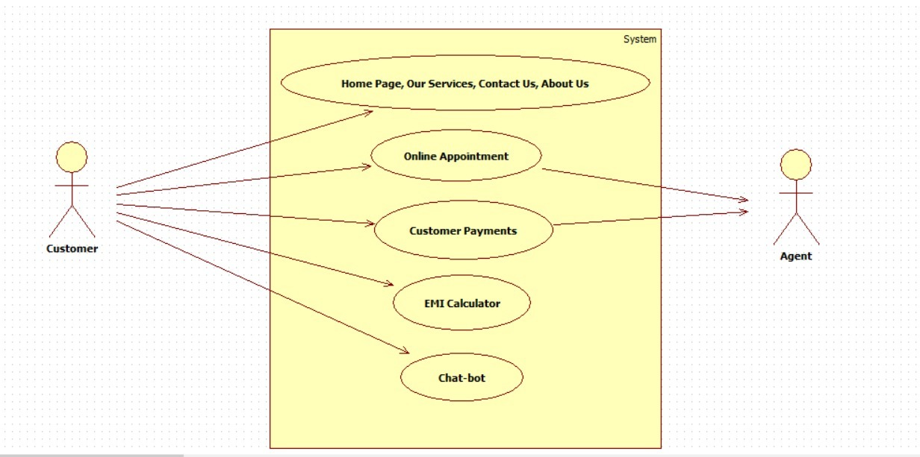

## System Structure

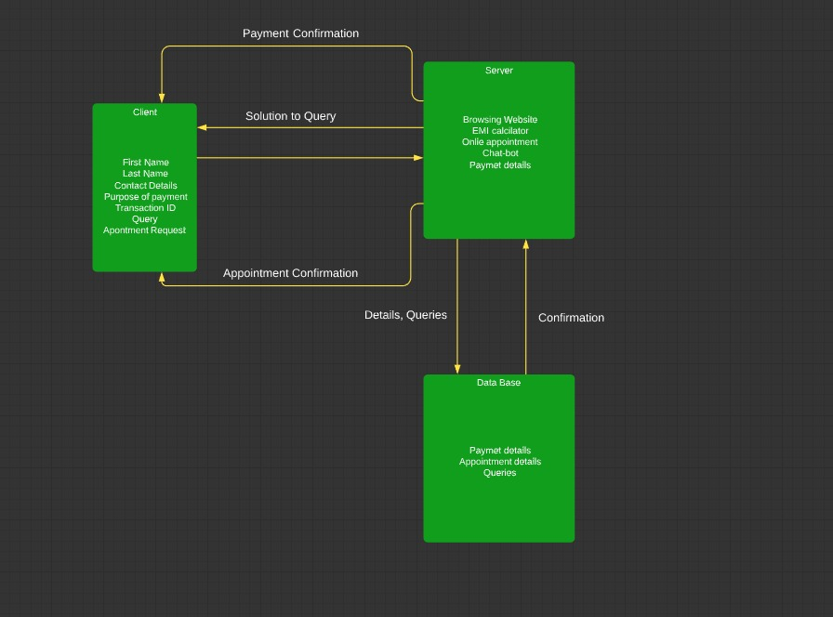

# High-Level Design

## Data Model

* + 1. **E-R Diagram**

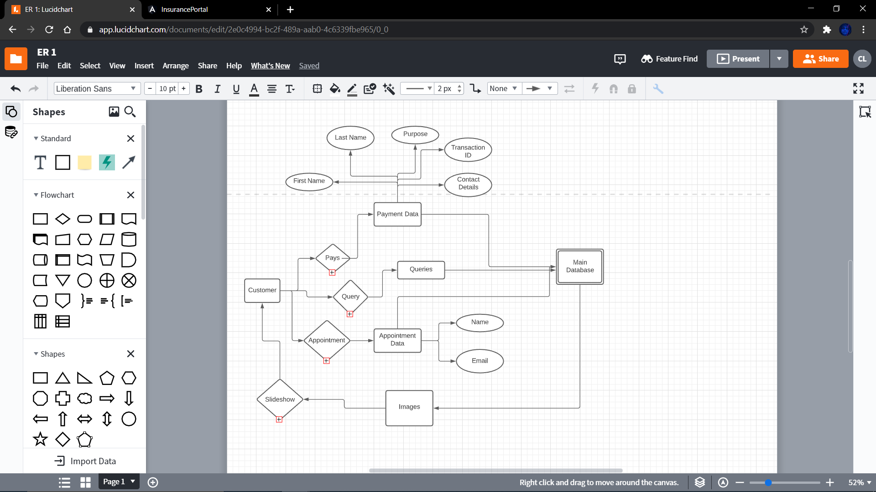

* + 1. **Database Design**

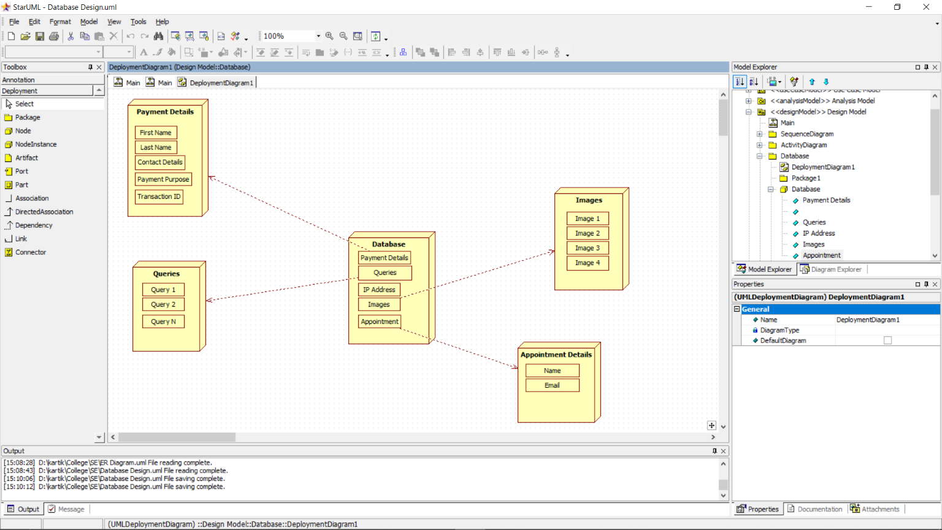

Database Table description:

1. Payment Detais

|  |  |
| --- | --- |
| First Name | First name of Customer |
| Last Name | Surname of Customer. |
| Contact Details | Contact no. of Customer |
| Payment Purpose | Reason for Payment of amount to the agent. |
| Transaction ID | A unique transaction ID generated at the end of Net banking. |

2. Queries

|  |  |
| --- | --- |
| Query | Feedback which comes from the Chatbot. |

3. Images

|  |  |
| --- | --- |
| Images | For the homepage slideshow. |

## Processing

* + 1. **Data Flow Diagrams / Sequence, Activity Diagrams**

Sequence Diagram:

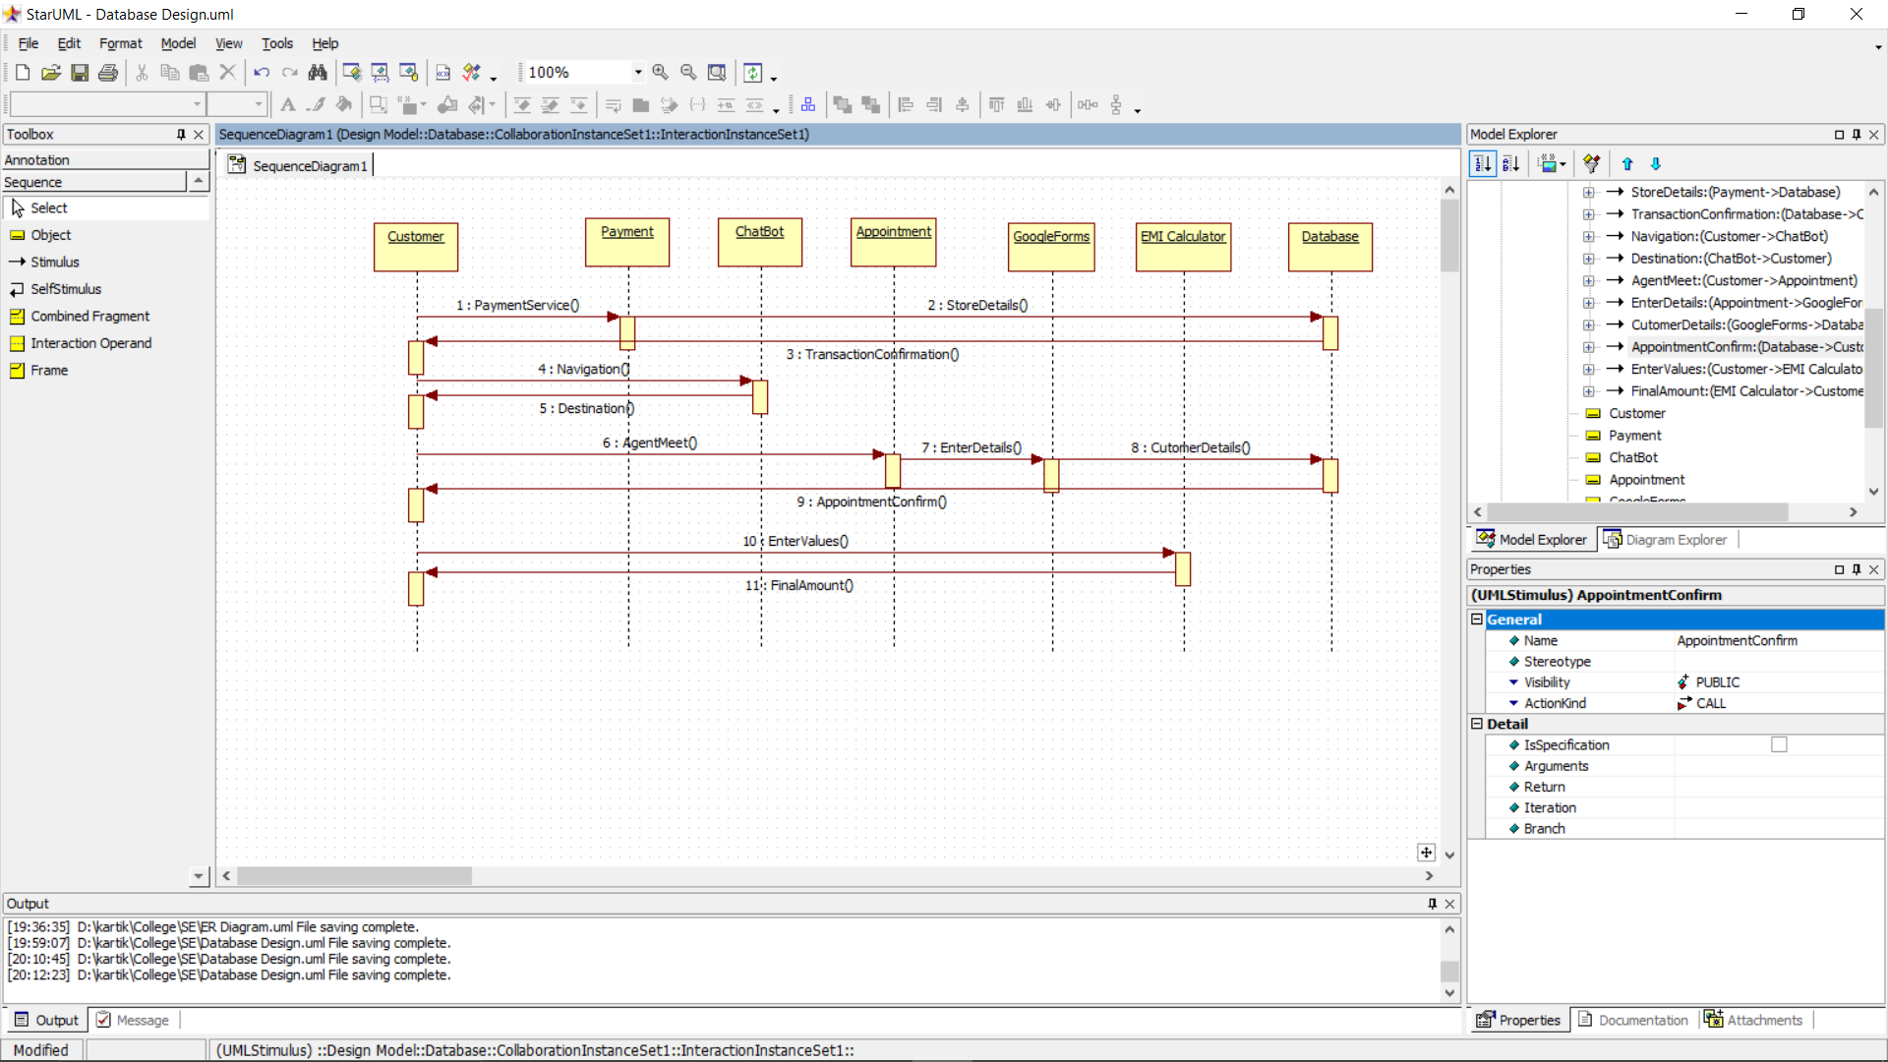

Activity Diagram:

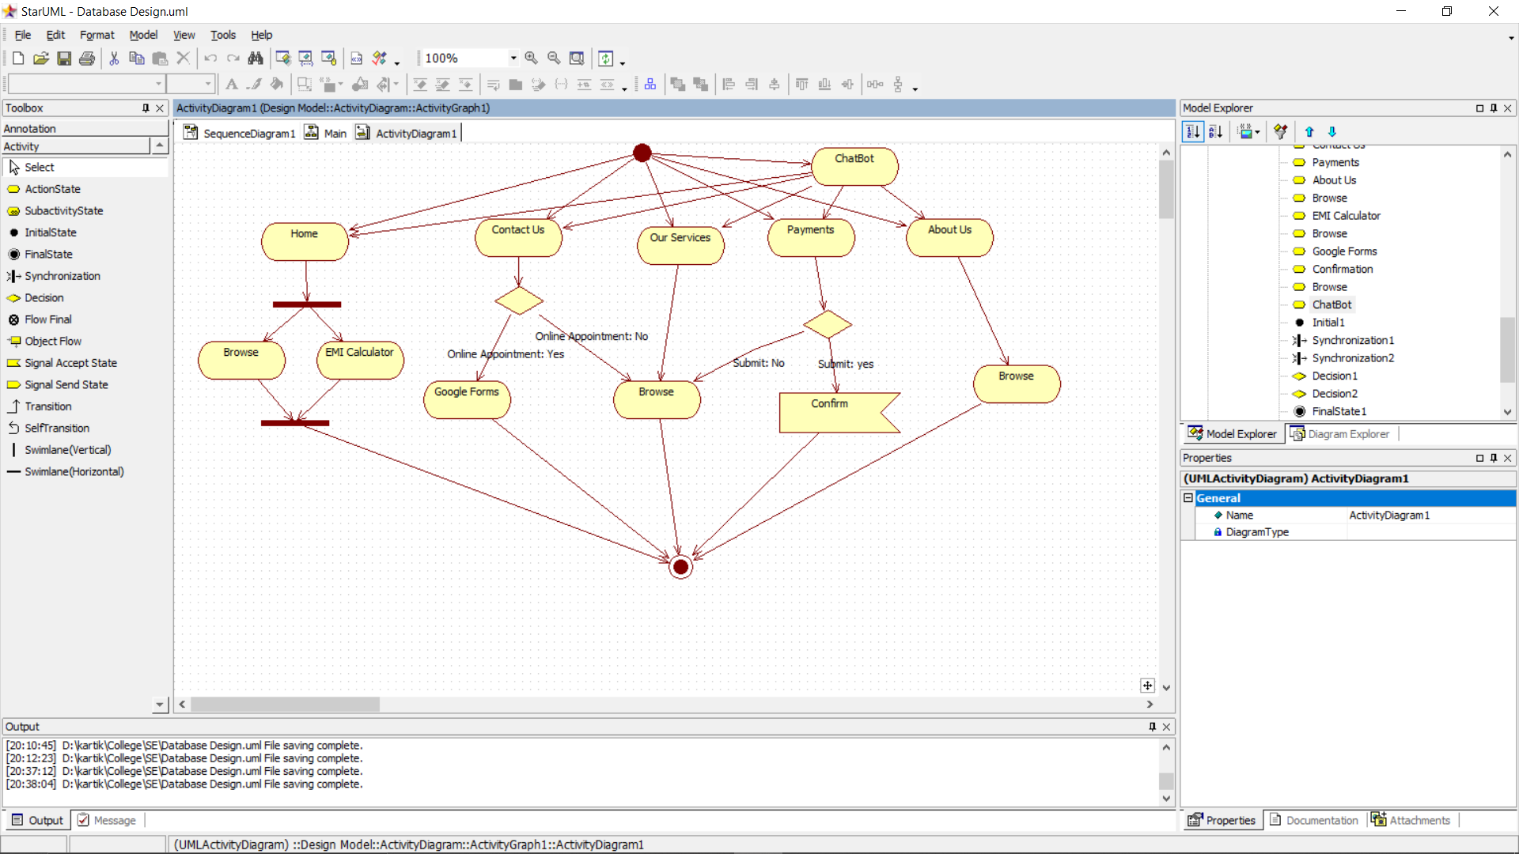

* + 1. **Modular Decomposition**

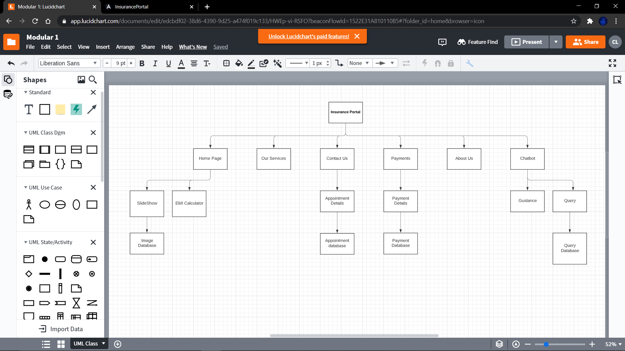

## User Interface Design

* Home Page:

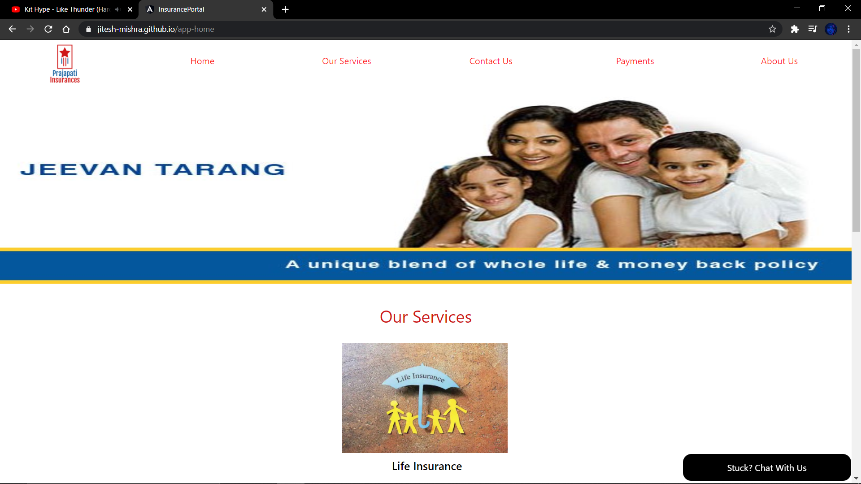

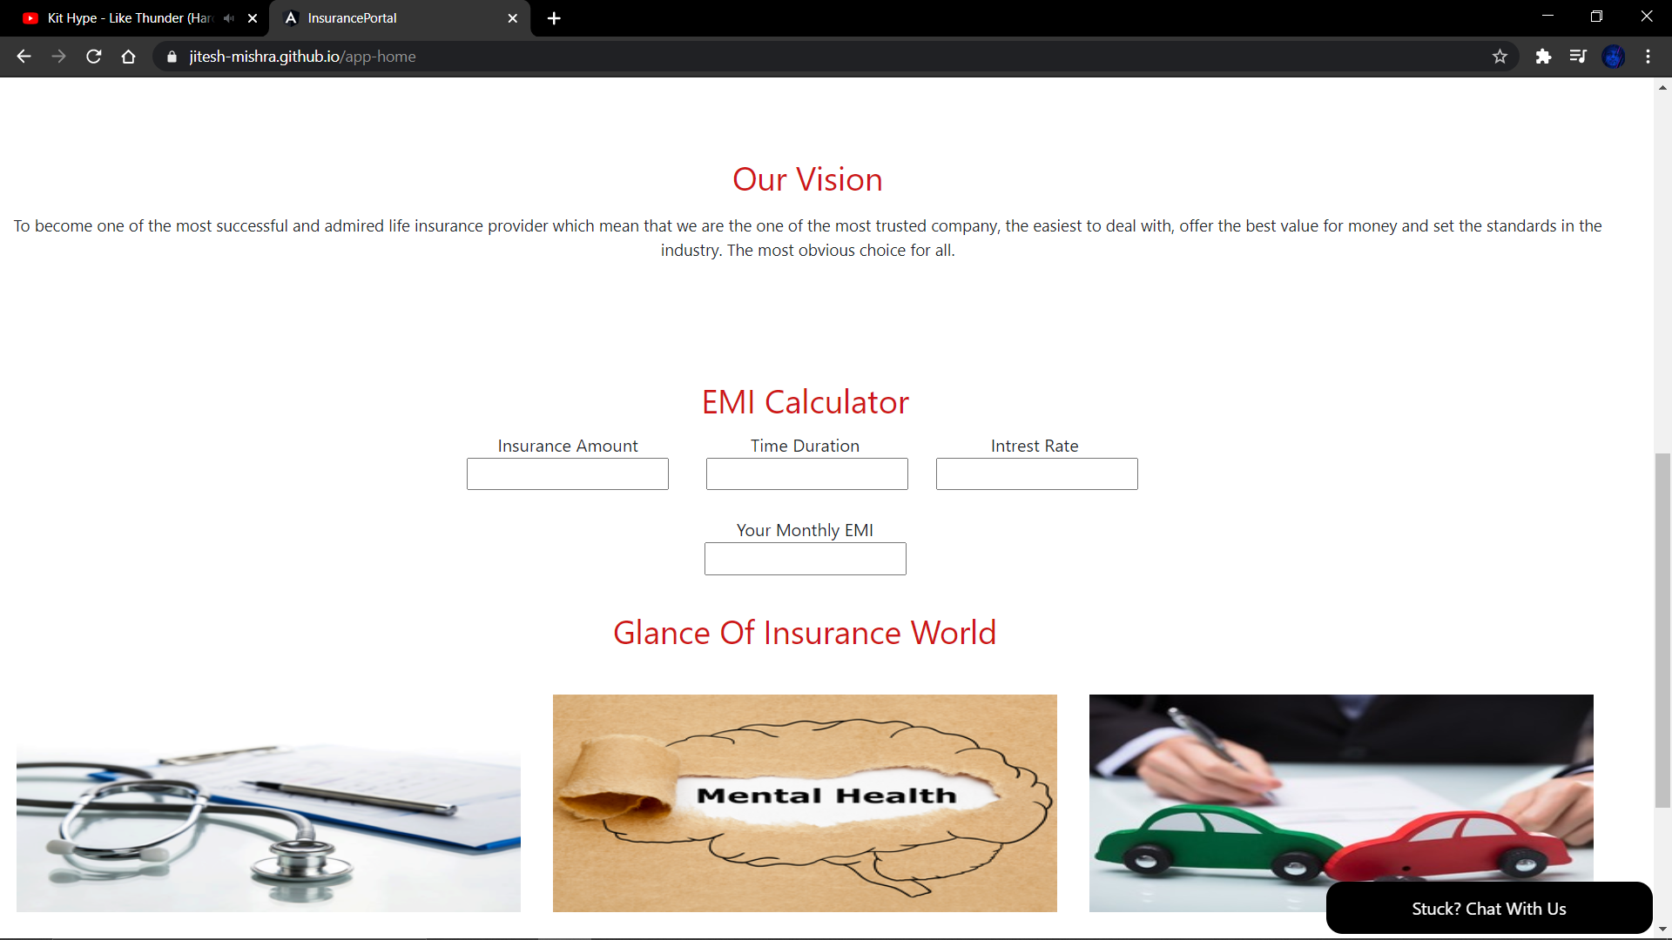

* Services Page:

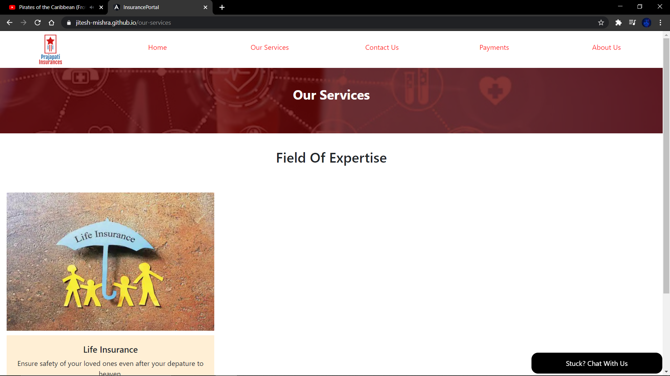

* Contact Page:

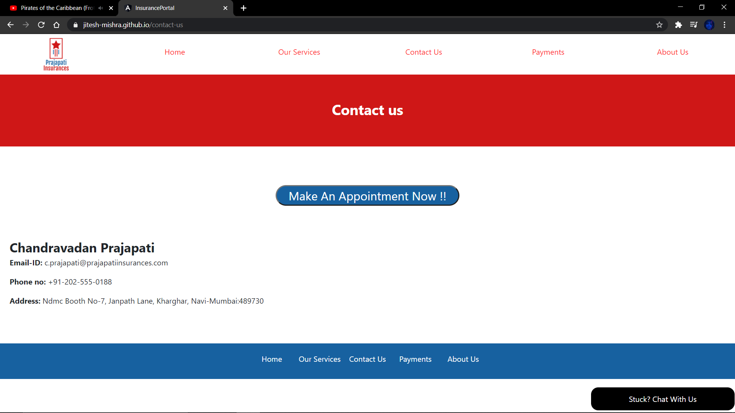

* Payments Page:

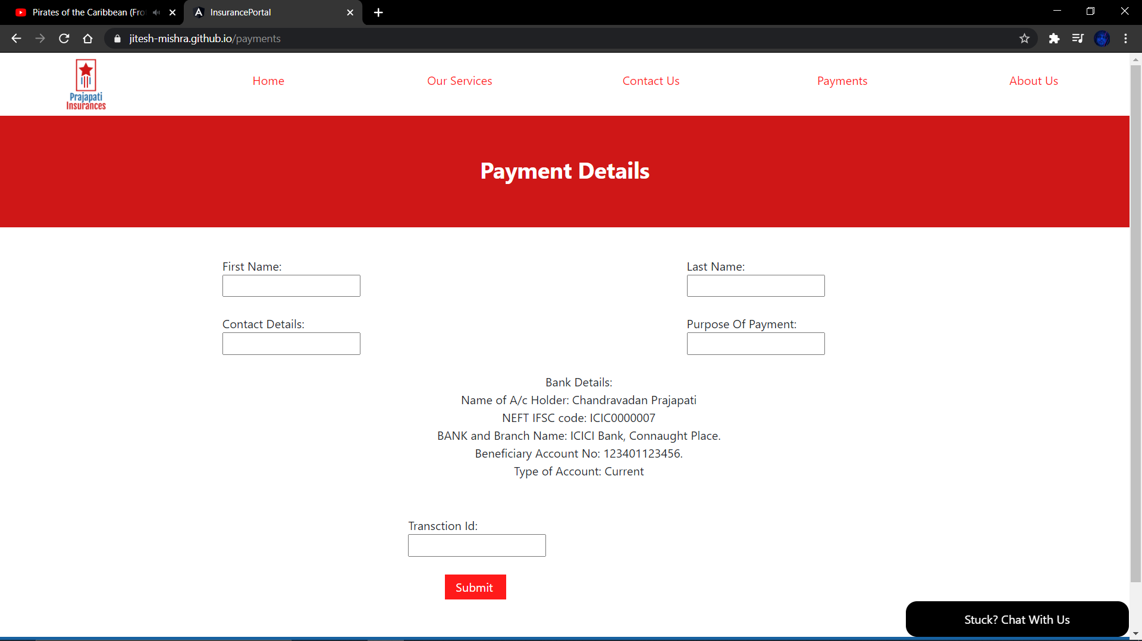

* About Us:

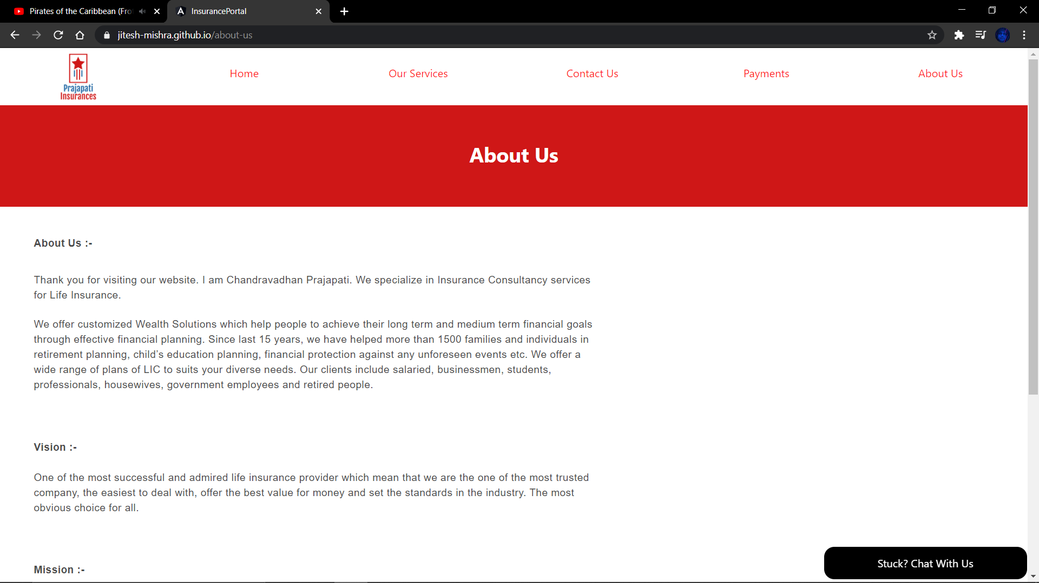

# Modular Specifications

|  |  |
| --- | --- |
| **HOME PAGE** | |
| Functions provided | * Horizontal Slider * Our Services * Our Vision * EMI Calculator * News Section |
| Requirement IDs | CB,LC,HS,NS (Refer RTT document for IDs) |
| The logic of the module | The homepage is the first page which will be shown to the user whenever he/she visits the site.  Here, they can see the vision, services, news, images and can calculate the EMI. |
| Interfaces to other modules | NIL |
| Third-Party Components /Externally sourced modules to be used | * Angular * Visual Studio Code |
| Inputs and Outputs | **Inputs:**  Emi Calculator  Amount, interest rate, time  **Output:**  Emi Calculator  Money to be given per month |
| Exceptions | Error in calculation in EMI since the client may add wrong information in the inputs and may not get the desired output. |

|  |  |
| --- | --- |
| **ABOUT US** | |
| Functions provided | Information about the client. |
| Requirement IDs | AB (Refer RTT document for IDs) |
| Logic of the module | Here the user will be able to see all the information of the insurance agent and will be able to know the agent even more closely from a business perspective |
| Interfaces to other modules | NIL |
| Third Party Components /Externally sourced modules to be used | * Angular * Visual Studio Code |
| Inputs and Outputs | NIL |
| Exceptions | NIL |

|  |  |
| --- | --- |
| **PAYMENTS** | |
| Functions provided | * Customer Data * Agent's Bank Details |
| Requirement IDs | PD (Refer RTT document for IDs) |
| Logic of the module | In this slide the user will be able to enters its data and will be able to get the agents bank acc details where he has to transfer the money. |
| Interfaces to other modules | NIL |
| Third Party Components /Externally sourced modules to be used | * Angular * Visual Studio Code |
| Inputs and Outputs | **Inputs:**  Customer data in the respective field  **Output:**  Payment Confirmed Screen with the agent and client acc details |
| Exceptions | NIL |

|  |  |
| --- | --- |
| **CONTACT US** | |
| Functions provided | * Text Area to Give Agent's Contact Details * Button Leading to Google Forms |
| Requirement IDs | AB,AP (Refer RTT document for IDs) |
| Logic of the module | In this page the user will be able to see the contact details of the agent and can also contact the client by writing its information in the google forms |
| Interfaces to other modules | Button Leading to Google Forms |
| Third Party Components /Externally sourced modules to be used | * Angular * Visual Studio Code * G - Forms |
| Inputs and Outputs | **Inputs:**  Google forms input of user contact details  **Output:**  Response submitted page in G-Forms |
| Exceptions | NIL |

|  |  |
| --- | --- |
| **OUR SERVICES** | |
| Functions provided | * Text Description of Services * Image Complementing to the text |
| Requirement IDs | SP (Refer RTT document for IDs) |
| Logic of the module | In this slide the user will be able to know about the services provided from the agent to the client. |
| Interfaces to other modules | NIL |
| Third Party Components /Externally sourced modules to be used | * Angular * Visual Studio Code |
| Inputs and Outputs | NIL |
| Exceptions | NIL |

|  |  |
| --- | --- |
| **CHAT-BOT** | |
| Functions provided | * Button to Open and Close Chat-Bot * 5 Navigation Links * Answer customer queries |
| Requirement IDs | CB (Refer RTT document for IDs) |
| Logic of the module | This bot is user defined which will navigate the user if he/she has doubt using the portal and this will be available in all the slides. |
| Interfaces to other modules | 5 navigation links which are:   * About us – navigates to About Us page * Contact us – navigates to Contact Us page * Payment – navigates to the Payment Details page * Home – will navigate to the Homepage * Services – will navigate to the Our Services page |
| Third Party Components /Externally sourced modules to be used | * Angular * Visual Studio Code |
| Inputs and Outputs | **Inputs:**  Users can get help navigating through website using chatbot.  **Output:**  Users can navigate through site using chatbot |
| Exceptions | NIL |

|  |  |
| --- | --- |
| **NAV-BAR** | |
| Functions provided | * 5 Navigation Text Links * 1 Navigation Symbol Links |
| Requirement IDs | AB (Refer RTT document for IDs) |
| Logic of the module | This is the navbar which will be available in the header pane of every page which will guide the user to respective location |
| Interfaces to other modules | 5 navigation links which are:   * About us – navigates to About Us page * Contact us – navigates to Contact Us page * Payment – navigates to the Payment Details page * Home – will navigate to the Homepage * Services – will navigate to the Our Services page   1 Navigation Symbol Links which navigates to the Homepage |
| Third Party Components /Externally sourced modules to be used | * Angular * Visual Studio Code |
| Inputs and Outputs | Navigation to different screens. |
| Exceptions | NIL |

|  |  |
| --- | --- |
| **FOOTER** | |
| Functions provided | * 5 Navigation Text Links |
| Requirement IDs | AB (Refer RTT document for IDs) |
| Logic of the module | This is the footer which will be available in the footer pane of every page which will guide the user to respective location |
| Interfaces to other modules | 5 navigation links which are:   * About us – navigates to About Us page * Contact us – navigates to Contact Us page * Payment – navigates to the Payment Details page * Home – will navigate to the Homepage * Services – will navigate to the Our Services page |
| Third Party Components /Externally sourced modules to be used | * Angular * Visual Studio Code |
| Inputs and Outputs | Navigation to different screens. |
| Exceptions | NIL |

|  |  |
| --- | --- |
| **SERVER** | |
| Functions provided | * Horizontal Slider * Customer Payment Data Collection * Appointment Data Collection from Google Forms * Customer Queries |
| Requirement IDs | HS, PD. AP, AB (Refer RTT document for IDs) |
| Logic of the module | This is the server phase of the project where all the data which will be inputted by client and will be see on the other end to the client who will have all the data base. |
| Interfaces to other modules | Button Leading to Google Forms |
| Third Party Components /Externally sourced modules to be used | * Angular * Visual Studio Code * G - Forms |
| Inputs and Outputs | **Inputs:**  Users can get help navigating through website using chatbot.  Google forms input of user contact details  Payment Details of customer  **Output:**  Response submitted can be viewed and edited by the agent.  Users can navigate through site using chatbot |
| Exceptions | Nil |

# Development Environment

* The software shall be developed in angular 10.
* Git-Hub and Google Forms are the additional tools that shall be used in the development.